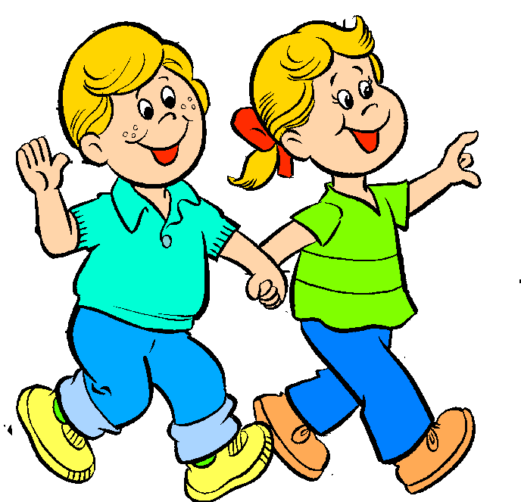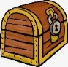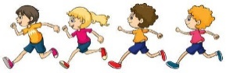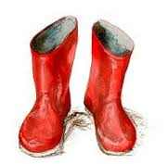

Reception – Autumn Term

**Marvellous me and the world**

**around me!**

This term, we will be finding out all about each other, learning about our new friends and building friendships.

We will be learning about different jobs in our local community and special events that happen in our lives. These are some of the questions we will be focusing on during the term.

**Communication and Language**

What’s in your treasure box? Why is it special to you? What is a question? Can you help me ask a question? What am I learning about? What do I like to do?

**Personal, Social and Emotional**How is your treasure box the same and different from your friend’s? What do you like/dislike? What do your friends like/dislike? What makes you happy or sad? Can you remember how we take care of our classroom? Why are some people special to us? What do you celebrate? Why do Christians celebrate Christmas?

**woods, etc…? What am I good at? What are my friends good at? Can you learn the names of your new friends? What makes them happy? Can you remember how we take care of our classroom?**

**Physical Development**

What do you need to wear outside? Can you put your own coat on? Can you help a friend? How do we keep safe?

Can you get changed for PE? We will be completing ongoing dance and PE sessions.

How do you take care of yourself – teeth cleaning/washing etc. Can you hold a knife and fork?

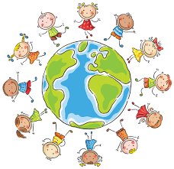

**Maths**

Can you find the numeral to match this number? What is our number of the day? What can we find our about this number? We will be working on number recognition, position work etc with houses. What number is your house? What numbers are next door to you? What shapes can you spot on our walk? Are all the signs we can see the same shape? What shapes do you spot at the front of our school? Can you count groups of objects? Can you sort groups of objects?

[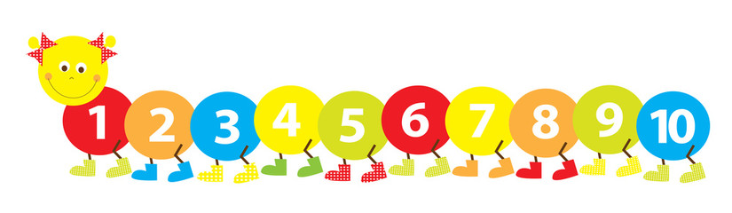](https://www.google.co.uk/url?sa=i&source=images&cd=&cad=rja&uact=8&ved=2ahUKEwjAme2i37nbAhUCkRQKHRVbC50QjRx6BAgBEAU&url=http://clipartmag.com/numbers-1-10-clipart&psig=AOvVaw3D54BjNv4I4fD5ZTlEvtPg&ust=1528192566455940)

**Literacy**

Have you done any writing before? What letters do you know? What do you know about writing? We will complete shared writing about your treasure boxes. What might your name start with? How will you hold the pencil? Where will you start writing?

How can you write ‘I am…?’ ‘I like…’ What words do you need to help you?

We will be starting to learn our phonics sounds.

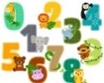

**Expressive Art and Design**

Can you print a set of your hands? Can you mix a range of colours to match your skin and hair colour?

Can you join in with our number rhymes? What song shall we learn and sing today?

**Understanding the world**   
What can you see in our area? What buildings are close to Castlewood? Where do you pass on the way to school? Who is in your family? Who works in our local area? Who helps us in our community? What are the signs of Autumn?



[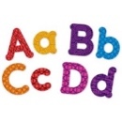](https://www.google.co.uk/url?sa=i&source=images&cd=&cad=rja&uact=8&ved=2ahUKEwjc76fi3rnbAhUBShQKHTsNCIAQjRx6BAgBEAU&url=https://www.learningresources.com/product/learning+essentials--8482-+magnetic+uppercase+and+lowercase+letters.do&psig=AOvVaw3TS4rTp_17YT1beppZ5Gcq&ust=1528192480057286)